Characteristics of research on the application of three-dimensional immersive virtual worlds in health
Reza Ghanbarzadeh¹, Amir Hossein Ghapanchi², and Michael Blumenstein²

^{1, 2} School of Information and Communication Technology, Griffith University, Gold Coast, Queensland, Australia
{reza.ghanbarzadeh@griffithuni.edu.au},
{a.ghapanchi, m.blumenstein@griffith.edu.au}

Abstract. Three-dimensional immersive virtual worlds (3DVW) offer researchers and health professionals the opportunities to experiment with their rich communication, collaboration, virtual and 3D content creation integrated tools. This study presents the results of a systematic literature review conducted on the adoption of 3DVWs in the health care sector. Our systematic review began with an initial set of 1088 studies from five major and top-ranking scientific databases published from 1990 to 2013 which have used 3DVWs in health. We found a large quantity of application areas for the 3DVWs in health care, and classified them into two main categories: educational and non-educational applications. We also analyzed different 3DVW platforms and virtual environments which have been used in health care, as well as the avatar-mediated roles these applications, and frequency of papers in different countries. Our findings can be very insightful for the health care community and researchers.

Keywords. Three dimensional virtual worlds; 3DVW; healthcare; health
- Introduction
Web 2.0, as a new technology, facilitates various applications and activities such as collaboration, interaction, social networking, and participation among users [1, 2]. One of the major applications of Web 2.0 is three dimensional immersive virtual worlds (3DVW). A 3DVW is a computer-generated, simulated, collaborative, interactive, networked, graphic, and multimedia environment, running on the web, and designed so that their users may ‘live in’ and interact using their own digital and graphical self-representations known as ‘avatar’ [3, 4]. Avatars have the ability to communicate with each other through text or voice tools, either privately or publicly, inside the virtual environments of 3DVWs. These 3D worlds mostly share the sufficiency and capabilities and of virtual reality technologies, especially the rendering of 3D environments, and they are accessible to the users through Internet-connected and high-speed PCs. 3DVWs also have capabilities that make them different from virtual reality and other web-based technologies. In particular, these worlds are collaborative and persistent (they exist even when users are not online and logged in) and, as a multi-user environment, they support social networking and interactivity [5, 6]. Importantly, the ability of customizing a personal avatar and using it to communicate with other avatars contributes to a new way of supporting people’s embodied subjectivity.
Information technology has made significant advancements which have impacted various aspects of human being life. So far, numerous research studies have been conducted on different effects of IT in a wide variety of fields [16-26] .Over the last decade, there has been a growing interest in the health care communities in using information technologies, especially, 3DVWs for medical purposes. 3DVWs currently feature a lot of medical and health-related projects, and they offer opportunities for different groups such as patients, physicians, providers, educators and health care institutions for improving the quality and efficiency of their care, treatment and education. They offer improved experiences to users and patients seeking health care information, skill building, health care education, group support, and individual consultation in terms of health. It is very important for the health care community and researchers to understand the impacts of using 3DVWs in their specific field, so they can consider the application of this technology in their own research, business or profession.
Previously several studies have been conducted related to this topic and we address some of them as follows. In [7], 3DVWs and their educational potential to health and medical educators and librarians have been introduced. Another study, [8], provides an overview of 3DVWs which are currently used in healthcare professional education and medicine. A survey of activities related to health on Second Life (www.secondlife.com) is conducted in [9]. The opportunities which are available for nursing students inside the multi-user virtual environment are presented by Peck and Miller (2010) [10]. The application areas of three-dimensional virtual worlds in the health care sector have been investigated in [12] and [13].
This paper conducts a systematic review of current studies into the application of 3DVWs in healthcare and medical contexts. This literature review helps us to shape the future direction of research by providing an understanding of previous studies, and recurring themes in the literature, and identifies gaps in the existing body of knowledge to date. This study seeks to respond to these research questions:
RQ1: For which medical purposes have 3DVWs been used by researchers and health professionals?
RQ2: What 3DVW platforms have been used by researches in health care?
RQ3: What kinds of environments have been developed using 3DVWs in health care researches?
RQ4: Which avatar roles have been simulated by 3DVWs in health care?
RQ5: In which countries have the studies related to applications of 3DVWs in health care been conducted mostly?
The remainder of this paper is organized as follows: Section two explains the applied research methodology for our systematic review. Section three presents the results, and section four concludes the article.
2 Research Methodology
In this study, we follow systematic literature review guidelines to achieve our research objectives. A systematic literature review is a methodical approach to identify, evaluate, and interpretation of the previous studies conducted on a specific research topic [11]. Previously, several studies have used this method to conduct a review on literature [14, 15]. The current section explains the research methodology of this study and identifies the inclusion and exclusion processes of papers, data extraction and analysis.
2.1 Search and select procedures
The search for relevant literature in the current study was performed in 6 stages. Fig. 1 indicates the stages of study selection for systematic review in this study according to Kitchenham [11] guidelines.

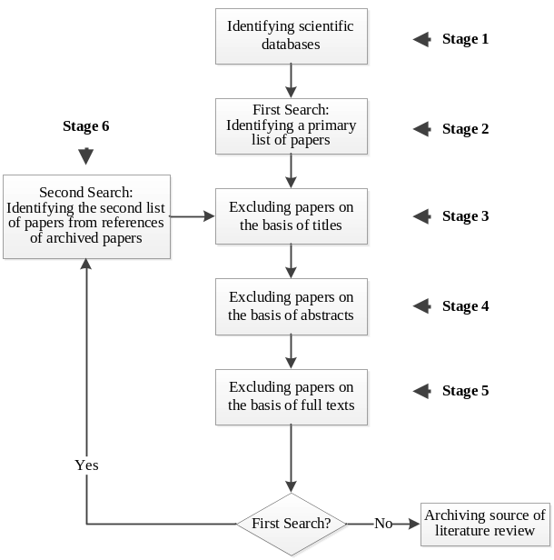
Fig. 1. Stages in the procedure of study selection.

In the first stage the scientific databases (see Section B) have been identified to search the key words. In Stage 2, a search of 42 keywords (see Section C) on those databases was carried out. As of July 20, 2013, our searches resulted in 1088 primary studies. As can be seen from the diagram in fig. 1, Stages 3 to 5 were undertaken two times in the search process. In the first iteration, in Stage 3, 789 papers were eliminated on the basis of their titles. In Stage 4, from the remaining 299 papers, 262 papers were excluded on the basis of their abstracts. The total number of relevant papers was 37. In order to increment the comprehensiveness of the study, we tried to increase the number of relevant papers. Therefore, we investigated the reference papers of those of 37 papers in Stage 6 which resulted in an additional 1183 papers. 1152 papers were excluded on the basis of their titles. Another six papers were excluded based on their abstracts, resulting in 25 remaining papers. Altogether, as of 20 Aug 2013, we found 2271 papers, of which 2209 were eliminated for being unrelated to our topic. Eventually, the total number of relevant papers in our systematic review was 62. There was not any paper elimination on the basis of the full text in either iterations. Table 1 represents a comprehensive summary of our search and paper selection process in each stage.
Table 1. Total number of remaining papers
 | First Search | References Included
Initial number of papers  Discarded by title  Discarded by abstract  Number of remaining papers | 1088  789  262  37 | 1183  1152  6  25
Total number of remaining papers | 62
2.2 Resources searched
Five main scientific databases were selected for the searching process: PubMed, ScienceDirect, ProQuest, IEEE Explore and ACM Digital Library.
2.3 Search Terms
The advanced search or expert search service provided by each scientific database’s search engine was used to carry out the search operations. Based on the search patterns offered by each database’s search engine, the title, abstract, key words and in some of the cases, the full text of articles, were sourced using the 42 various search terms including the keywords related to ‘three dimensional’, ‘virtual world’, and ‘health’.
2.4 Inclusion and exclusion criteria
In the current systematic review, in order to select materials, two inclusion and exclusion criterion were considered:
1) During the search process in all of the above-mentioned databases, a publication date filtration was carried out and we included studies published between January 1990 and July 2013.
2) The studies in languages other than English were excluded.
2.5 Data extraction
Two kinds of data were extracted from 62 studies in this systematic review: 1) Application areas of 3DWV in healthcare. 2) 3DVW platforms, virtual environment, avatar-mediated roles, year of publication and country of studies. Microsoft Excel 2010 and Microsoft Visio 2010 were used for data collection and analysis, drawing diagrams and designing the tables.
2.6 Data Analysis
In order to accomplish a data analysis, we read the title, abstract and full text of the 62 extracted papers. Our goal was to classify these papers into meaningful categories. Therefore, we tried to insert each paper in an appropriate category based on the main area of research of that article. At the end of the first stage, all the articles were classified according to different categories. To clarify our classification, we revised our categorizing operation several times and finally we grouped all of the extracted papers to two major research categories. After that, we attempted to extract additional information from the articles required for our systematic review, such as health contexts, 3DVW platforms, avatar roles, virtual environments, year of publication, and country of publication. Fig. 2 demonstrates the procedure undertaken to achieve the data analysis process.

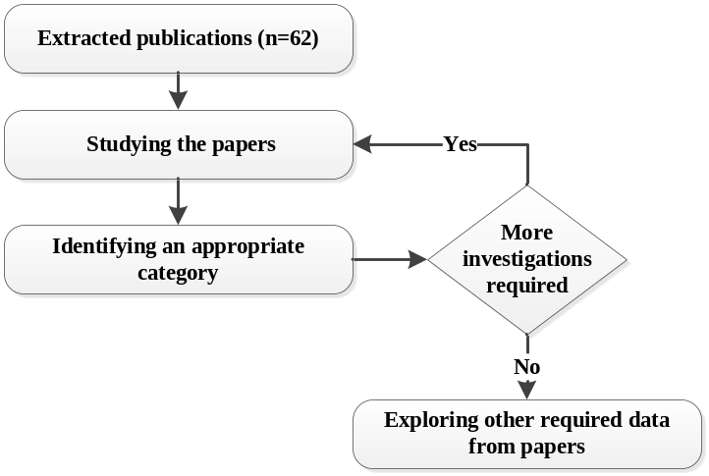

Fig. 2. Stages in the data analysis procedure
3 Results
As mentioned previously, this study seeks to answer five research questions in conjunction with the application areas of 3DVWs in the health care sector. Below are the research questions and discussion.
3.1 RQ1: For which medical purposes have 3DVWs been used by researchers and health professionals?
3DVWs have been used in a vast majority of application areas in the health care sector and health-related activities. In order to gain a general understanding of 3DVW research, as previously mentioned, we classified all the studies on 3DVW into two categories: educational and non-educational application. Fig. 3 shows the number of published studies in each category. As can be seen from the chart, the education category includes the largest number of papers, namely 34. In contrast, 24 papers are related to non-educational application of 3DVWs in health care. From the total of 62 papers, 4 papers conducted surveys and literature reviews on this field [7-10].

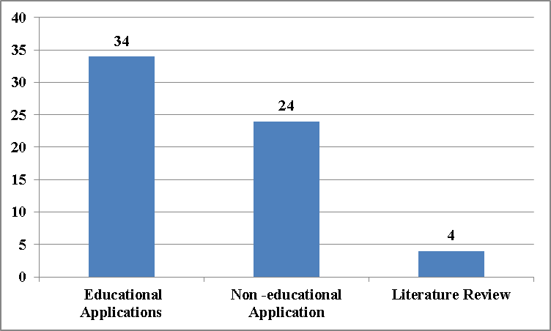
Fig. 3. Number of papers based on the categories
A. Educational Applications
As mentioned, from the total number of 62 papers, 34 studies have used 3DVWs for pedagogical and educational applications in health care. These studies mostly focused on academic and professional education programs which are related to training programs for students and staff in educational communities and universities as well as education in professional health care communities such as training programs for physicians, nurses, and hospital staff for different health contexts like public health, radiotherapy, emergency, safety, pharmacy and clinical medical etc.
B. Non-educational Applications
Studies in this group mostly discuss the use of 3DVWs in several areas such as simulation, treatment and assessment in health. In some studies, patients, nurses, physicians or other medical staff had their own avatars entered in a specific environment in 3DVWs and patients were treated using specialized techniques. Other studies have applied 3DWVs for simulating a replica of hospital, health care logistics, e-health marketing, and public health. For example, a replica of a university lab, a hospital, a ward, an emergency ward, or an operating room has been created virtually inside the various islands of the 3DVWs. Other studies have used these worlds for evaluation and assessment of a particular proficiency in specific groups like nurses and sergeants, or measurement of a factor in emergency services, or investigating a rate of improvement in a patient.
3.2 RQ2: What platforms have been used by 3DVW researches in health?
In particular, the highest number of papers used Second Life as their study’s 3DWV platform, 77.42%. Of the remaining 22.58% of platforms, 16.13 % of studies applied their own self developed virtual world, and the other 6.45% used different platforms like Open Simulator, Virtual-U, Active Worlds and 3D ICS, each 1.61%. These statistics show that Second Life is the most well-known of the 3D virtual worlds which have been used in health care. Fig. 4 demonstrates percentages of different 3DWV platforms applied in the literature.

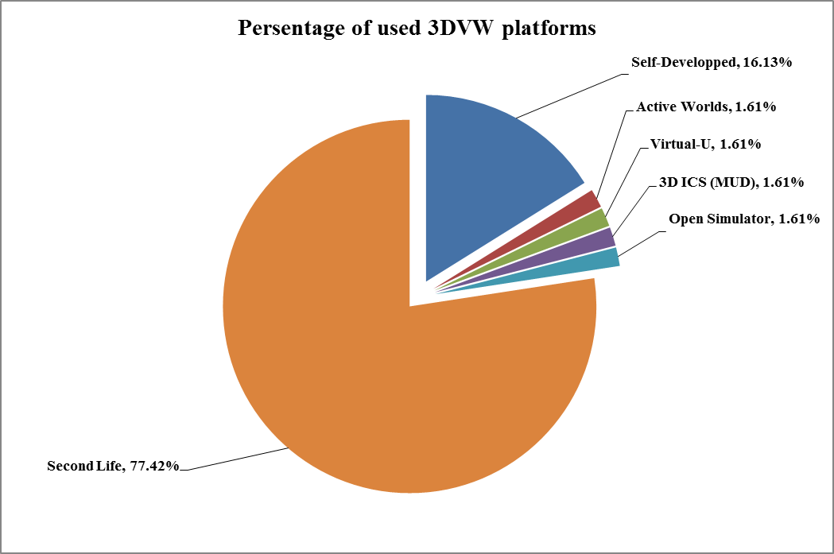

Fig. 4. Percentage of applied 3DWV platforms in health care
3.3 RQ3: What types of environments have been developed using 3DVWs in health researches?
In all of the studied articles in the two application areas of 3DWVs, different virtual environments have been designed, developed and used. We divided them into the following six environments:
- Gaming environments
- Virtual training environments
- Virtual medical environments
- Special islands inside the virtual worlds
- Virtual houses
- Other virtual environments

The most applied environments in the literature were virtual medical environments with 29% of all. These environments were virtual health-related areas built inside the 3DVWs for medical purposes such as virtual hospitals, virtual ICUs, virtual emergency wards, virtual physician’s offices, and virtual pharmacies.
The virtual training environments, with 26% of all environments, are the next kind of these areas which were locations such as virtual classrooms, virtual campuses, virtual board room, or a virtual replica of a university campus for educational and training purposes in health care.
14% of the studies used the existing virtual islands in 3DVWs in their works for health specific purposes. Popular 3D virtual worlds like Second Life have several built-in islands for various purposes and users of these worlds can teleport there and use them for their own related works.
7 % of all the papers studied in our literature review, created virtual house environments for their health-related works in a house-like environment.
Gaming environments are other kinds of virtual environments which have been applied by 3% of studies. In these environments, the users of 3DVWs mostly play a specific game which is designed inside the virtual worlds to learn about a particular concept.
The remainder of the studies, 21%, used other virtual environments in their works. Some of these environments were virtual exhibitions, virtual parking lots, virtual meeting rooms, virtual accidents, and virtual chat rooms.
Fig. 5 depicts the distribution of the papers across the virtual environments.

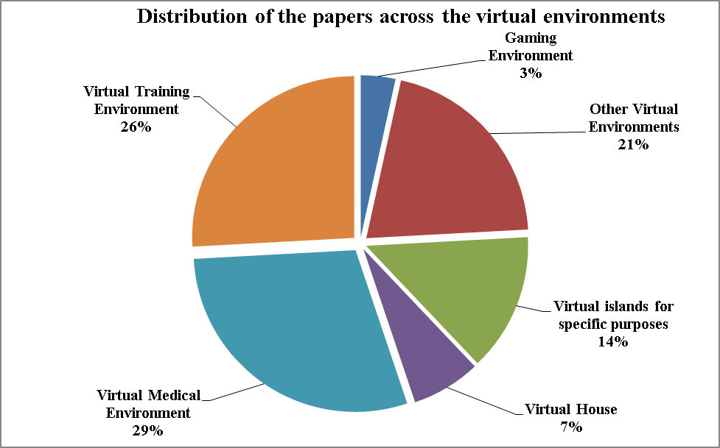

Fig. 5. Distribution of the papers across the virtual environments
3.4 RQ4: Which medical and non-medical roles have been simulated avatars by 3DVWs in health?
3DVW environment are most often populated by avatars, which are controlled by users of the virtual worlds. Avatars are users’ own digital and graphical self-representations and people can ‘live in’ these worlds and interact using their own avatars. Avatars can be represented in humanoid form, as an animal, a mythical figure, an imaginary or contrived figure or object.
In various applications of 3DVWs, different roles of participants may be implemented using avatars. In our systematic literature review, we tried to identify the roles of participants in each study and classify them into meaningful classifications. According to the roles in each application area which played with avatars, we categorized them into two main groups; user participant avatars and instructor participant avatars.
User participant avatars mostly play roles such as medical professionals, patients, students and other avatars which get some health care and educational services in the applications. In contrast, instructor participant avatars undertake the roles that provide health care and educational services for other avatars. We divided these roles to medical professional, instructor, patient, supervisor and other avatars. Some studies didn’t need to have instructor participant avatars.
In the first category, 28 studies had avatars in the role of a student who participated in educational health care services in 3DVWs. Eleven studies used avatars for the role of patient and 13 studies used medical professional roles for avatars in their works. Six papers used avatars in other roles such as veterans, teens, common visitors and volunteers.
In the second category, avatars with the role of instructor and medical professionals were used in 15 and 10 studies respectively. Authors in 16 papers applied patient avatars in their studies. Ten studies didn’t have instructor participant avatars, while 3 studies used other avatars such as virtual human agents.
Fig. 6 and Fig. 7 show the user and instructor participant avatars and their distribution in the studies, respectively.

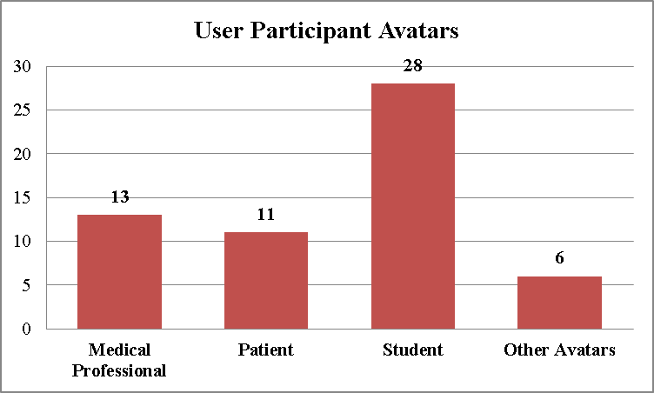
Fig. 6. Distribution of user participant avatars in the literature

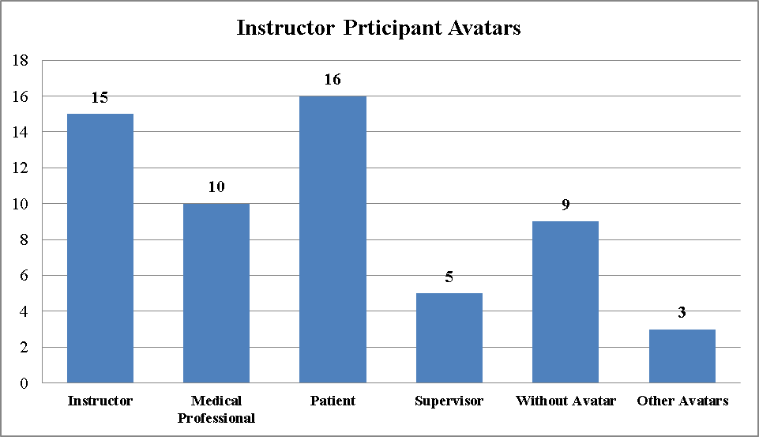
Fig. 7. Distribution of instructor participant avatars in the literature
3.5 RQ5: In which countries have the studies related to applications of 3DVWs in health care been conducted mostly?

Fig. 8 shows a percentage of the extracted papers in different countries around the world. Most of the articles relate to authors affiliated with the United States of America, which is around 60% of total studies. The United Kingdom, with 13% of publications, is the next largest source of papers in this field. In the third ranking, with 5% of publications each, are Australia, Canada and Italy. The remaining 12% of papers came from Japan, Sweden, Korea, Hong Kong, New Zealand and Israel.

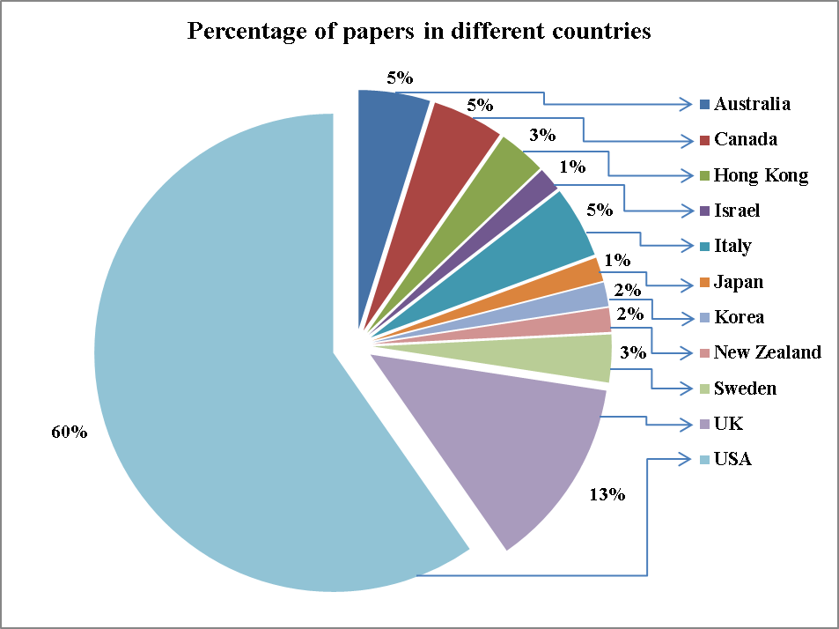

Fig. 8. Frequency of papers in different countries

Fig. 9 illustrates the number of published papers per year. As can be seen from the chart, between 1990 and 2005 there are no papers related to 3DVWs in healthcare contexts. The number of published papers per year increased significantly from 1 to 13 between 2006 and 2010 decreasing to 9 in 2009. There is a decline to 10 papers in 2011 and to 8 in 2012. As our research was in July 2013, 3 papers were published in this year prior to this date.

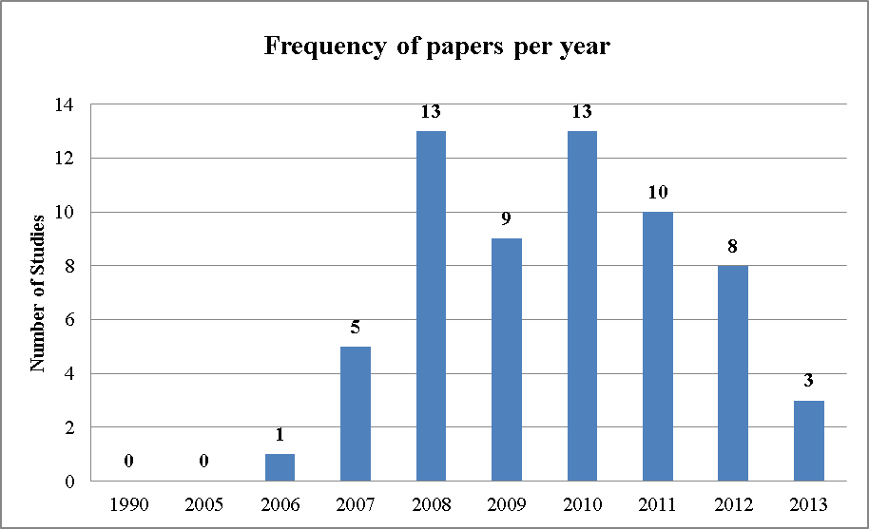
Fig. 9. Frequency of papers per year
4 Conclusion
3D Virtual Worlds offer several innovative ways to carry out health-related activities. In this study we developed two main categories to explain the application of 3DVWs in various healthcare contexts: Educational and Non-educational applications. We also classified the different applied 3DVW platforms, virtual environments, and avatar-mediated participant roles which have been used in the literature. We found that Second Life is the most used 3DVW in health care application. We also found that most of the studies relate to this topic have been conducted in the United States of America. Our findings can be used to provide an overview of the application of 3DVWs in healthcare and medical research which professional health communities and academic institutions can use in their professions, researches, implementations and studies.
References

- Eysenbach, G., Medicine 2.0: social networking, collaboration, participation, apomediation, and openness. Journal of Medical Internet Research, 2008. 10(3)
- Boulos, M.N.K. and Wheeler S.: The emerging Web 2.0 social software: an enabling suite of sociable technologies in health and health care education1. Health Information & Libraries Journal, 2007. 24(1): p. 2-23.
- Bell, M.W.: Toward a definition of “virtual worlds.” Journal of VirtualWorlds Research, (2008), 1(1), 2–5.
- Boulos, M.N.K. and Burden, D.: Web GIS in practice V: 3-D interactive and real-time mapping in Second Life. International Journal of Health Geographics, 2007. 6(1): p. 51.
- Morie, J.F. and Chance E.: Extending the reach of health care for obesity and diabetes using virtual worlds. Journal of diabetes science and technology, 2011. 5(2): p. 272-276.
- Montoya, M.M., Massey A.P., and Lockwood N.S.: 3D collaborative virtual environments: exploring the link between collaborative behaviors and team performance. Decision Sciences, 2011. 42(2): p. 451-476.
- Boulos, M.N.K., Hetherington, L. and Wheeler, S.: Second Life: an overview of the potential of 3‐D virtual worlds in medical and health education. Health Information & Libraries Journal, 2007. 24(4): p. 233-245.
- Hansen M.M.: Versatile, Immersive, Creative and Dynamic Virtual 3-D Healthcare Learning Environments: A Review of the Literature. 2008.
- Beard, L., Wilson, K., Morra, D., and Keelan, J.: A survey of health-related activities on second life. Journal of Medical Internet Research11, no. 2 (2009).
- Peck, B. and Miller, C.: I think I can, I think I can, I think I can… I know I can Multi-user Virtual Environments (MUVEs) as a means of developing competence and confidence in undergraduate nursing students An Australian perspective. Procedia-Social and Behavioral Sciences, 2010. 2(2): p. 4571-4575.
- Kitchenham, B.: Procedures for performing systematic reviews. Keele, UK, Keele University, 2004. 33: p. 2004.
- Ghanbarzadeh, R., Ghapanchi A.H., Blumenstein M., and Talaei-Khoei. A.: A Decade of Research on the Use of Three-Dimensional Virtual Worlds in Health Care: A Systematic Literature Review., Journal of medical Internet research 16, no. 2 (2014).
- Ghanbarzadeh, R., Ghapanchi A.H., and Blumenstein, M.: Application areas of multi-user virtual environments in the healthcare context., Studies in health technology and informatics 204 (2013): 38-46.
- Amrollahi, A., Ghapanchi, A.H. and Talaei-Khoei, A.: A systematic literature review on strategic information systems planning: Insights from the past decade. Pacific Asia Journal of the Association for Information Systems 5, no. 2 (2013).
- Ghapanchi, A.H., Ghapanchi, A.R., Talaei-Khoei, A., and Abedin, B.: A Systematic Review on Information Technology Personnel’s Turnover. Lecture Notes on Software Engineering 1, no. 1 (2013): 98-101.
- Ghapanchi, A.H., Jafarzadeh, M.H. and Khakbaz, M.H.: An Application of Data Envelopment Analysis (DEA) for ERP system selection: Case of a petrochemical company. ICIS 2008 Proceedings (2008): 77.
- Ghapanchi, A.H., and Aurum, A.: Measuring the effectiveness of the defect-fixing process in open source software projects. System Sciences (HICSS), 2011 44th Hawaii International Conference on. IEEE, 2011.
- Ghapanchi, A.H., and Aurum, A.: The impact of project capabilities on project performance: Case of open source software projects. International Journal of Project Management 30.4 (2012): 407-417.
- Zarei, B., and Ghapanchi, A.H.: Guidelines for government-to-government initiative architecture in developing countries. International Journal of Information Management 28.4 (2008): 277-284.
- Ghapanchi, A.H., Aurum, A., and Low, G.: Creating a Measurement Taxonomy for the Success of Open Source Software Projects, First Monday, 16(8), 2011
- Ghapanchi, A.H., Aurum, A., and Daneshgar, F.: The Impact of Process Effectiveness on User Interest in Contributing to the Project, Journal of software, (2012), Vol. 7, No. 1, pp. 212-219.
- Merati, E., Zarei, B., and Ghapanchi, A.H.: Project Process Re-engineering (PPR): A BPR Method for Projects, International Journal of Information Systems and Change Management, (2010), Vol. 4, No.4 pp. 299 - 313.
- Ghapanchi, A.H., and Aurum, A. : Competency Rallying in Electronic Markets: Implications for Open Source Project Success, Electronic Markets, (2011), Vol. 22, No. 2, pp. 117-127.
- Ghapanchi, A.H., and Aurum, A.: The Impact of Project License and Operating System on the Effectiveness of the Defect-Fixing Process in Open Source Software Projects, International Journal of Business Information Systems, (2011), Vol. 8, No. 4, pp. 413-424
- Najaftorkaman, M., Ghapanchi, A.H., Talaei-Khoei, A., Ray, P.: Recent Research Areas and Grand Challenges in Electronic Medical Record: A Literature Survey Approach”, The International Technology Management Review, (2013) 3(1), 12-21.
- Najaftorkaman, M., Ghapanchi, A.H., Talaei-Khoei, A., Ray, P.: A Taxonomy of Antecedents to User Adoption of Health Information Systems: A Synthesis of Thirty Years of Research, Journal of the Association for Information Science and Technology, (2014)

